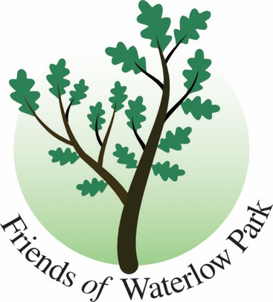

Friends of Waterlow Park Update

Highgate Breakfast Club to be held 13 April 2024.

LOOKING BACK –

The Friends’ committee shared a stall at Lauderdale House’s Heritage Weekend together with historian Pam Cooper 24 February and launched a new Park Treasure Trail featuring listed artworks in the park. Downloadable from the website. www.waterlowpark.org.uk

24 March as part of the Happier Outdoors event, the Friends amazed us all with a new Dog Show. Held in collaboration with and supporting All Dogs Matter (rescue charity) it was a runaway success. Opened by Caroline Catz, TV wife of Doc Martin.

Camden’s public consultation on whether to preserve some of the key views to the City from the Park by reducing the height of a lime tree was narrowly rejected as a plan.

LOOKING FORWARD –

The Biodiversity Surveying of the park’s plants starts again aided by volunteers giving an hour of their time on a Saturday. If you would like to help please contact biodiversity@waterlowpark.org.uk

The Gardening Volunteers are back on Monday and Thursday mornings. Work has begun on the memorial physic garden below the Lauderdale lawn.

Our AGM date is 11 June 2024, 6.30pm (drinks) for 7.00pm at LUX.
Keynote speakers, garden designer Peter Reader and Friends Deputy Chair April Cameron. All welcome, members only can vote.

Ends

chair@waterlowpark.org.uk
13 April 2024

